Berat Asrın CAFEROĞLU

Marmara Unıversıty | 150718056

Simulation Project

Arithmetic Multiplication Function Using OpAmps

# Log Function Circuit

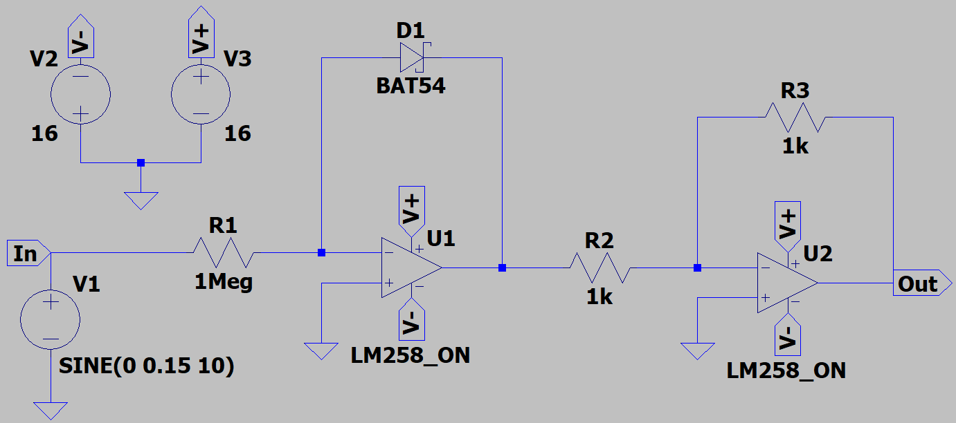Operational amplifiers play important role in our daily applications. One of their applications is analog logarithm function circuit. Let us give the “Log Function Circuit” and explain the reason behind the circuit.

Figure 1: Logarithm Circuit

Let us consider the circuit step by step and prove that it takes natural logarithm of input, in other words this circuit shows the natural logarithm of input with multiplied a constant.

Consider the input terminal of U1 and apply KCL in that node. Then,

When we measure , we can simplify the diode current into . Using this information,

Notice that, here . Then,

The problem occurred here is that we have natural logarithm in the output but with negative sign. So that, to make it true we should use inverter. In my design, stage 2 which contains operational amplifier name represents inverting stage, and gain of inverter part is 1.

Let us examine the second stage by making KCL at input node of second operational amplifier.

Not let us bring together the equations that are obtained above.

As it is seen above, natural logarithm of input signal is multiplied with some constant and output is obtained. We can simplify the equation as,

Here we said that the gain of second operational is 1, that is, . Therefore, equation is simplified to:

Let us explain the reasons behind the component selections.

1. resistor is selected as , because to design good and stable amplifier we desire to have big input resistance.
2. Diode is selected as BAT54 due to its low threshold voltage. Thereby, even low voltages can make diode saturated. Notice that, it is Schottky diode.
3. Operational amplifier is selected as LM258, because:
   1. Low Noise Interference
   2. Wide Bandwidth
   3. Large Gain
   4. It is known for its mathematical expression abilities.
4. Feeding voltages are connected 16 Volts symmetrical, because the operational amplifier that we use supports maximum Volts.
5. and are selected , they are not that high because only purpose of second stage is inverter, not amplifier.

Let us test the designed circuit and obtain output graphs, then compare the graphs with theoretical shapes.

## **DC Voltage Source**

We know that DC voltage is the voltage that does not depend on time, in other words it supplies constant voltage always. So that, the voltage line is horizontal linear line, then if we take its natural logarithm, we expect horizontal linear line again but with different voltage value.

Let us give , and observe the output.

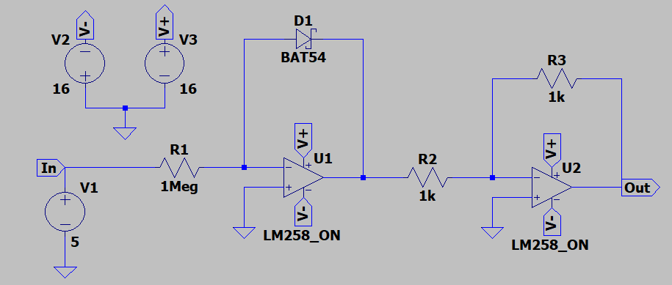

Figure 2: Log Circuit of DC Input

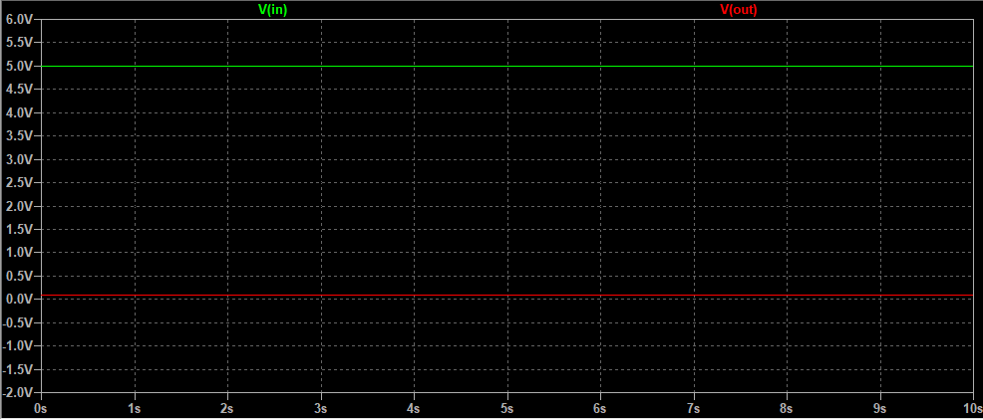

Figure 3: Input and Output Graphs

As it is seen from Figure 3, our expectation is true. Because at input side voltage values are always the same, that is, in the output they will always be the same too. But please notice that the voltage values are different at input and output sides.

## **AC Voltage Source**

Now the circuit will be tested using sinusoidal input. Before testing circuit let us check the theoretical output shape.

If the input is sinusoidal, we can estimate the theoretical shape using MATLAB.

t= 0:0.0001:50;

f= log(sin(t)); %log = natural logarithm in MATLAB

plot(t,f);

xlabel("t (sec)");

ylabel("voltage (volts)");

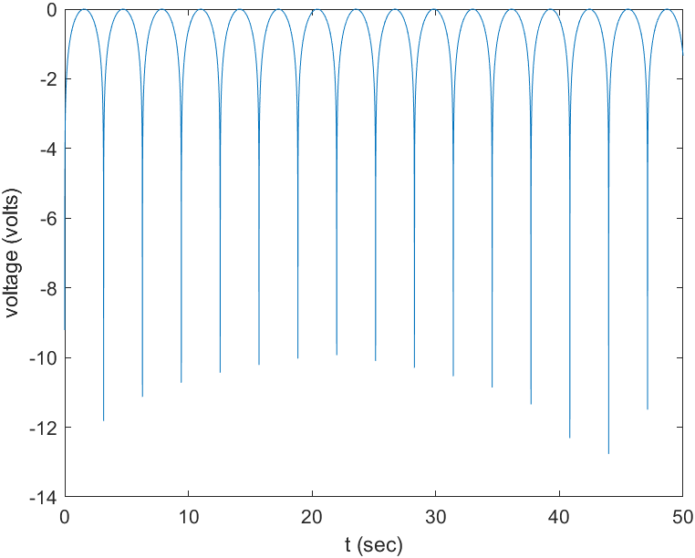

Figure 4: Output of AC Input

Figure 4 shows the output waveform when the input is sin(t). Therefore, by looking the output graph we can say that we expect one-directional output with some hills. Output waveform is like full-wave rectifier circuit output but without any filtering (without capacitor) to smooth fluctuation.

Now to test the circuit we will use sinusoidal input again. In experimental circuit used values are:

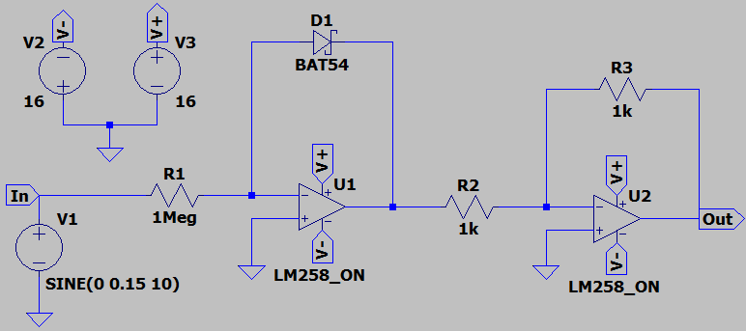

Figure 5: Log Circuit of AC Input

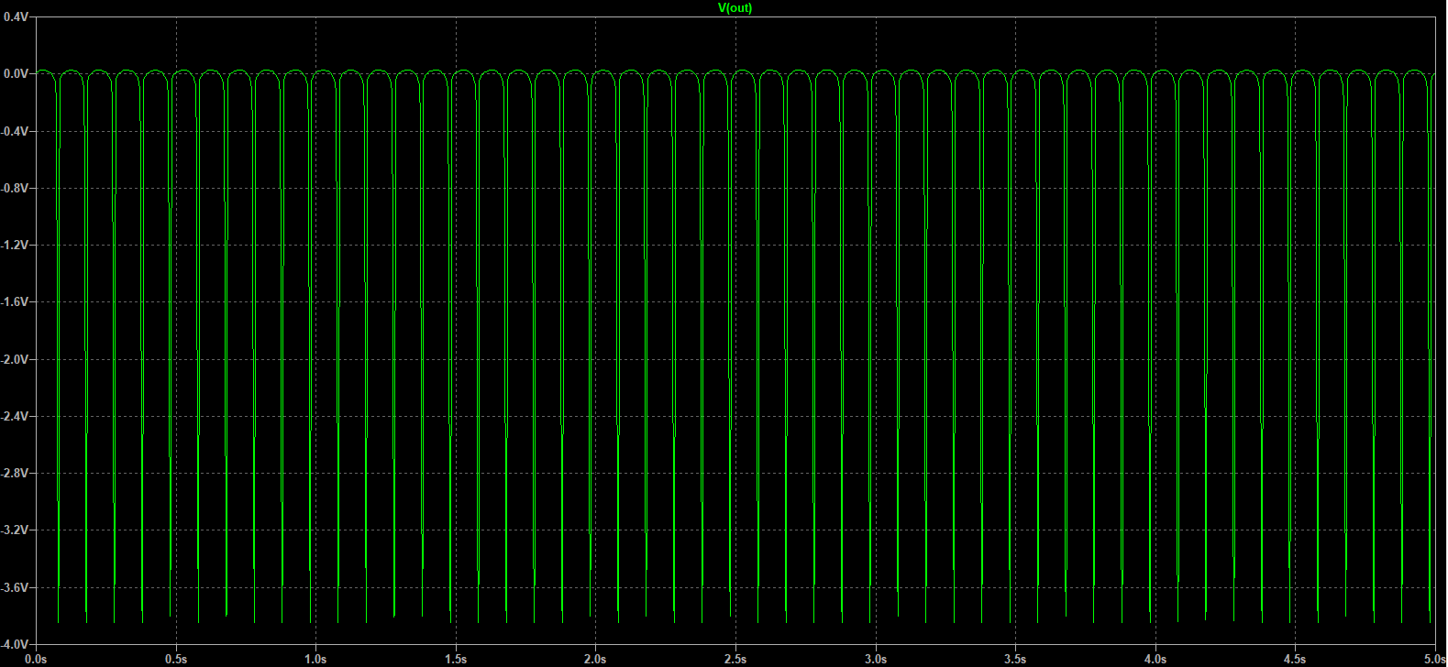It is clearly seen that Figure 6 supports our expectations in Figure 4. So that, circuit takes the natural logarithm of sinusoidal sources but with some constant.

Figure 6: Output of AC Input

## **Linear Voltage Source**

In this part we will examine the voltage source that is increasing proportional with time.

Let us find the theoretical shape of using MATLAB.

t= 1:0.0001:100;

f= log(t); %log = natural logarithm in MATLAB

plot(t,f);

xlabel("t (sec)");

ylabel("voltage (volts)");

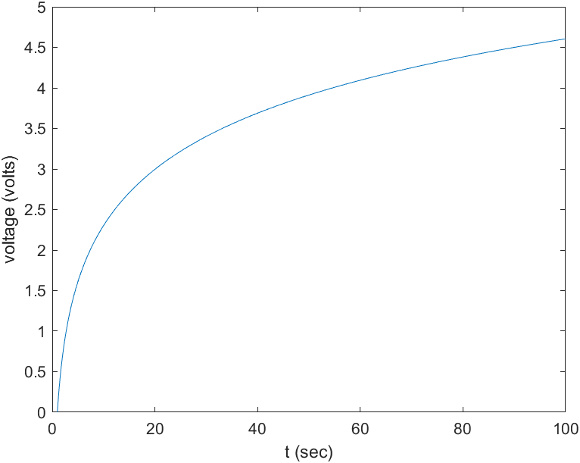

Figure 7: Output of Linear Input

Figure 7 simply shows natural logarithm graph because of . Now let us test the circuit, we expect the same shape but with the different values because of constants. In test circuit we will use the same input which is,

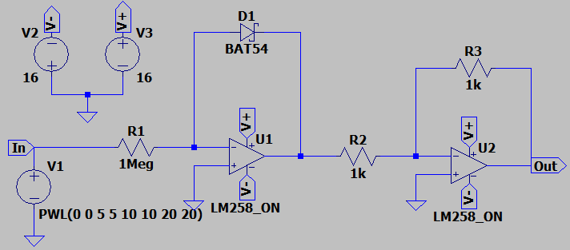

Figure 8: Log Circuit of Linear Input

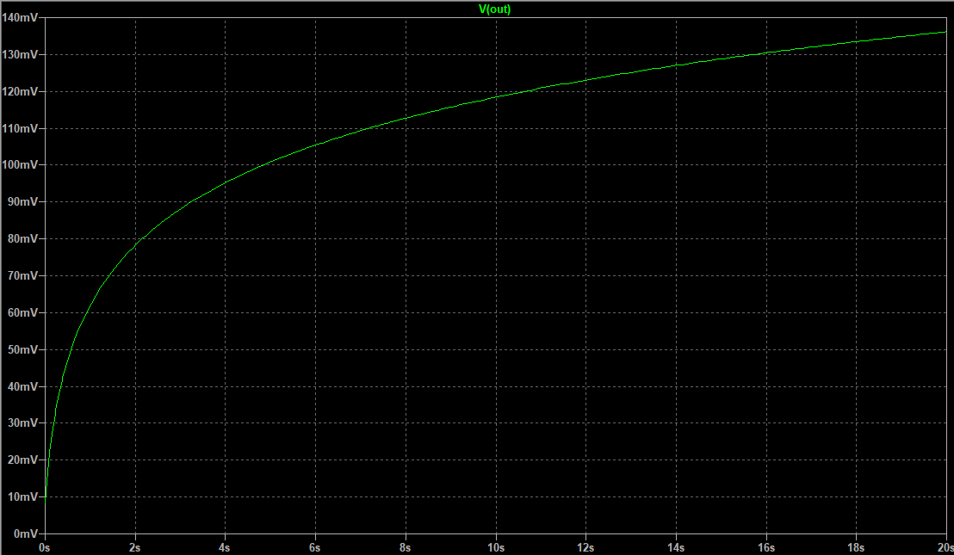

Figure 9: Output of Linear Input

We can clearly say that Figure 7 and Figure 9 matches, but as we expected only voltage values are different because of constants. Otherwise, output waveform or shape are the same.

After all these tests we can be sure that logarithm function circuit works very well. After this let us move on to antilog circuit design.

# Antilog Function Circuit

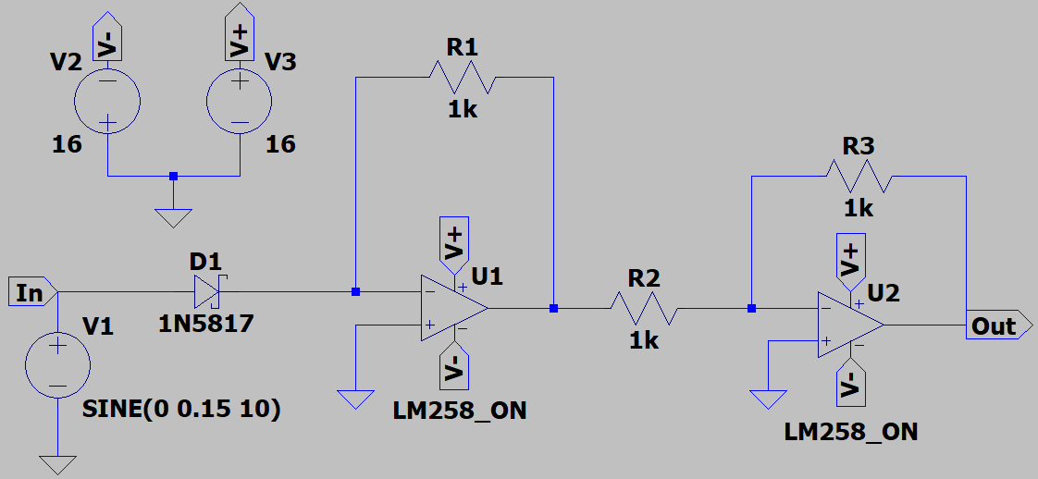Another important usage of operational amplifiers is “Antilog Function Circuit”. This circuit takes antilog of given input and shows it in the output with multiplied by some constant. We know that antilog of natural logarithm is here x is the input. So that, if e occurs in the output, we can say that design makes antilog calculation.

Figure 10: Antilog Function Circuit

Let us consider the circuit step by step and examine the output. First, we will take input node of first operational amplifier into account.

When we measure , we can simplify the diode current into . Using this information,

Notice that, here . Then,

The problem occurred here is we have antilog in the obtained equation, but with negative sign. Then, to correct the output waveform we can use simple inverter operational amplifier with gain of 1. Second stage works in that way exactly.

Let us consider the input node of second operational amplifier and apply KCL. Then,

Second stage is only used to invert not to amplify, then . Thereby, equation is simplified to:

It is proved that this circuit shows the antilog of input at the output. Before testing different types of inputs let us explain the component selections.

1. Because of its low threshold voltage 1N5817 Schottky diode is selected. The circuit is tested with BAT54 and 1N5817 and observed the waveforms then it is seen that 1N5817 is better to use in antilog operations.
2. Resistors are selected as because we do not want to amplify the input. We would like to obtain the output waveform of input. Also, it is cheap to use, and easy to find in laboratory.
3. Operational amplifier is selected as LM258, and feedings are due to same reasons explained in “Log Function Circuit”.

Now it is time to test designed circuit and compare theoretical expectations and real results.

## **DC Voltage Source**

We know that DC voltage is the voltage that does not depend on time, in other words it supplies constant voltage always. So that, the voltage line is horizontal linear line, then if we take its natural logarithm, we expect horizontal linear line again but with different voltage value.

Let us give , and observe the output.

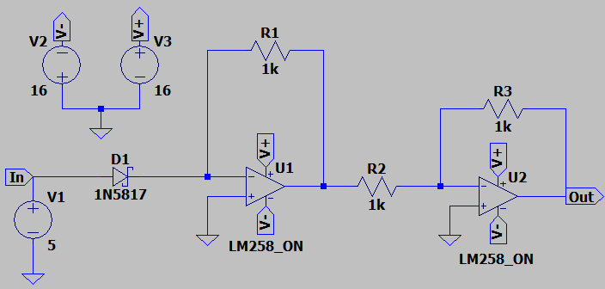

Figure 11: Antilog Circuit of DC Input

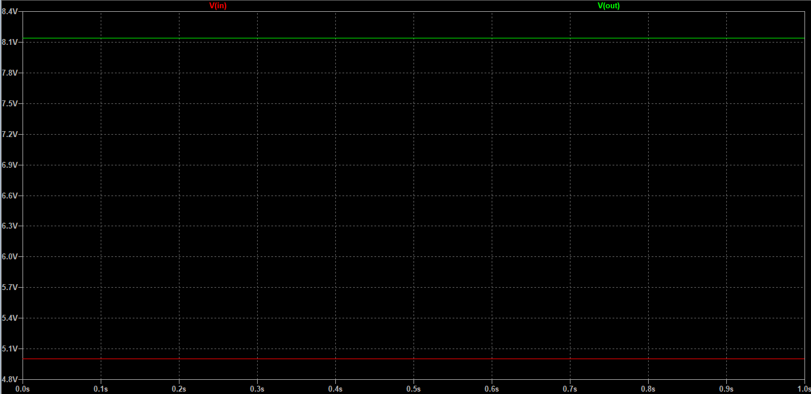As it is seen from Figure 12, our expectation is true. Because at input side voltage values are always the same, that is, in the output they will always be the same too. But please notice that the voltage values are different at input and output sides.

Figure 12: Output of DC Input

## **AC Voltage Source**

Now let us test the designed antilog circuit using sinusoidal input. Using MATLAB, we can find the theoretical shape. Let us find the output waveform of sin(t) input.

t= 0:0.0001:20;

f= exp(sin(t));

plot(t,f);

xlabel("t (sec)");

ylabel("voltage (volts)");

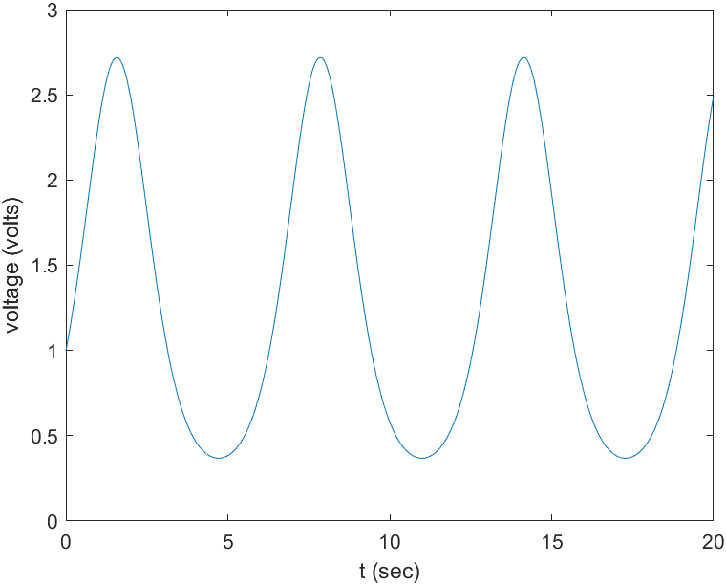

Figure 13: Output of AC Input

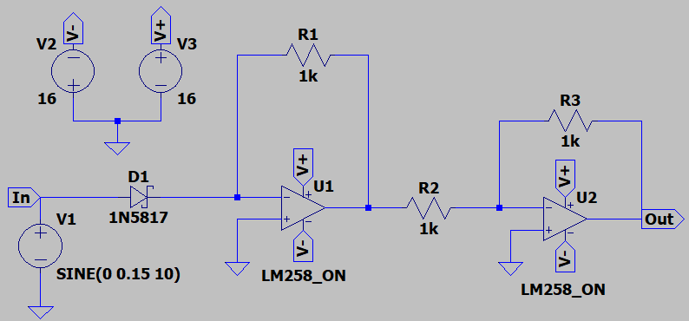We see that in Figure 13, it is very close to sinusoidal waveform shape, but it is not, because the negative half cycle is wider than positive half cycle. Another important point is please notice that there is no negative voltages.

Figure 14: Antilog Circuit of AC Input

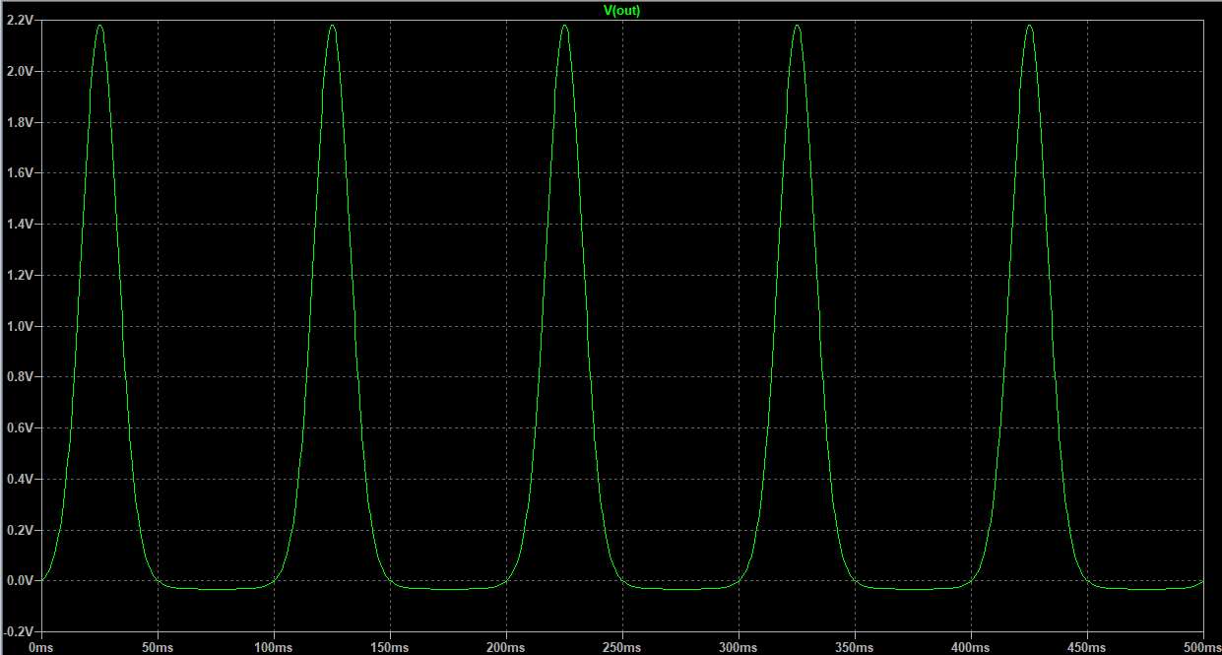

Figure 15: Output of AC Input

It is alright to say that Figure 14 almost matches with Figure 13. Therefore, the circuit response supports our expectations in theory.

## **Linear Voltage Source**

Now we will examine the linear voltage source such as . Let us find the theoretical waveform using MATLAB.

t= 0:0.00001:10;

f= exp(t);

plot(t,f);

xlabel("t (sec)");

ylabel("voltage (volts)");

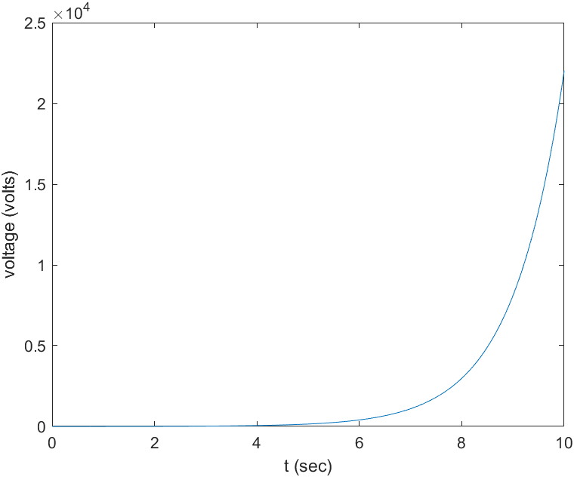

Figure 16: Output of Linear Input

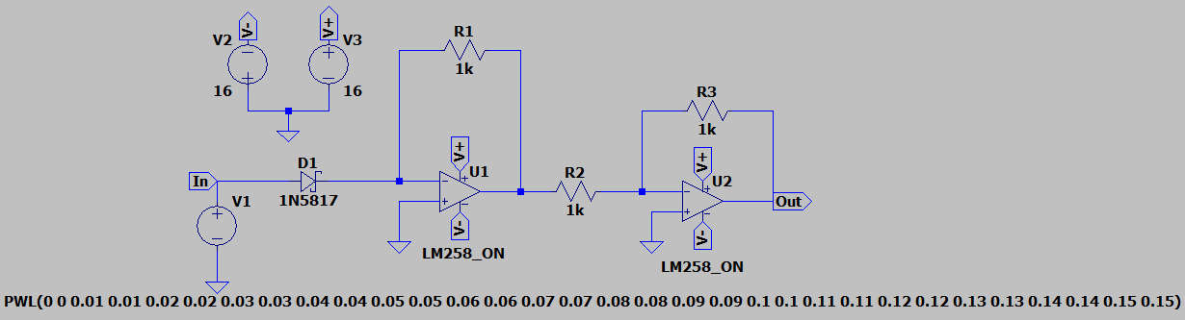Figure 16 simply shows the graph of because the input function is . Now let us test with the designed circuit. We expect the same output graph but with different values due to constants.

Figure 17: Antilog Circuit of Linear Input

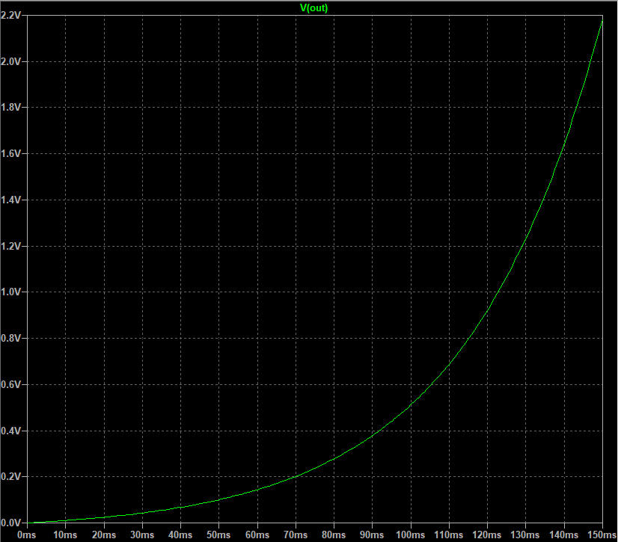

Figure 18: Output of Linear Input

It is seen that Figure 16 and Figure 18 are similar. Thereby, we can conclude that the output is true.

After all these tests, it is proved that antilog circuit works well and correct.

So far, we have designed logarithm function circuit and antilog function circuit which are important in multiplication and division circuit designs. In other words, these two circuits are the building blocks of multiplication and division circuits. In the coming section, we will design multiplication circuit which is based on log-antilog principles.

# Multiplication Function Circuit

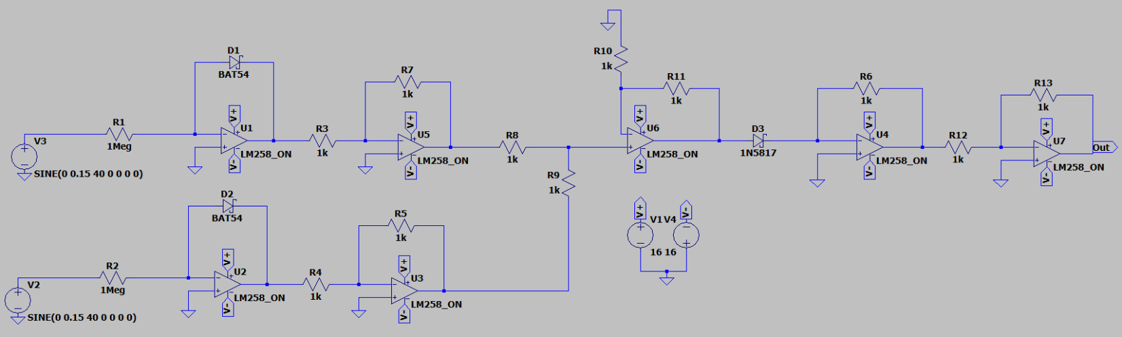In analog electronics multiplication process is done by using log-antilog principles. Let us show the designed circuit and explain it step by step.

Figure 19: Multiplication Function Circuit

Let us explain the circuit using block diagram.

INVERTER

INVERTER

INVERTER

ANTILOG

SUM

LOG

LOG

Now if we consider the block diagram step by step: (Assuming parameters are the same for all diodes.)

Step 1: Natural logarithm of inputs are calculated.

Step 2: Negative sign is not desirable. Therefore, inverters are used.

Step 3: Remember the property of logarithm. , that is, non-inverting summing amplifier is required to use.

Step 4: Take its antilog.

Step 5: Negative sign is not desirable. Therefore, inverter is used.

Notice that, inputs are multiplied and scaled with some constant K.

## **DC Voltage Source**

We know that DC voltage is the voltage that does not depend on time, in other words it supplies constant voltage always. So that, the voltage line is horizontal linear line, then if we take its natural logarithm, we expect horizontal linear line again but with different voltage value.

Let us give , , and observe the output.

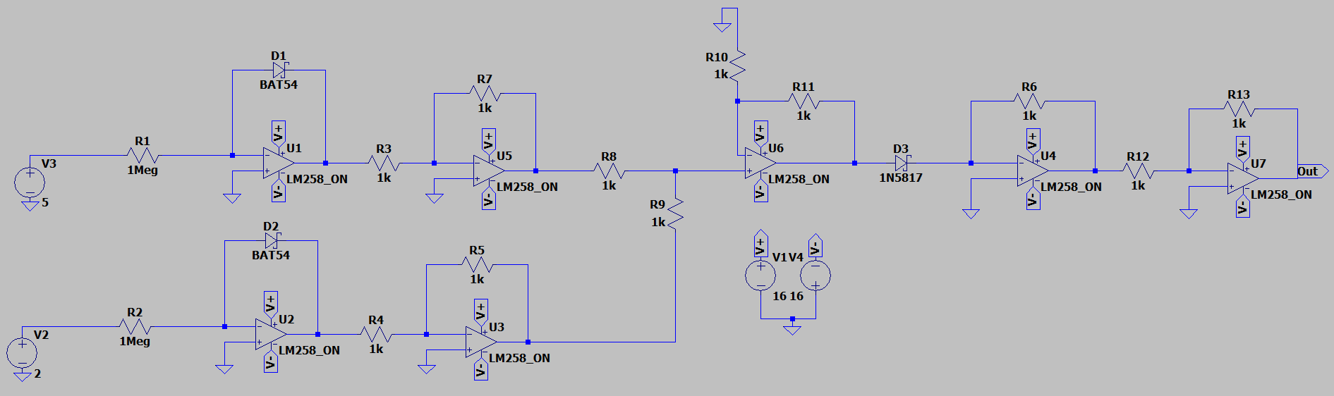

Figure 20: Multiplication of DC Inputs

We see that both inputs are in the DC form. Please remember the formula of multiplication circuit,

According to the formula that is obtained above output should be in DC form because all values are independent of time. Then, voltage at output is,

Here important point is to obtain K constant using datasheets. It is not topic of here we only desire to obtain waveforms.

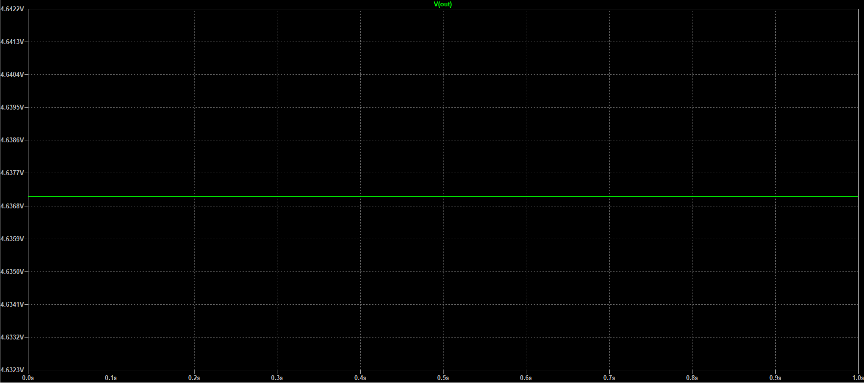Figure 21 shows the output of multiplication circuit using DC inputs, and it satisfies our expectations.

Figure 21: Output of DC Input

## **AC and Linear Voltage Sources**

Now we will try to obtain multiplication of sinusoidal input and linear input. The inputs that are used in experiment are:

If we consider multiplying them, we say that linear voltage source is increasing with time. So that, every t unit increases peak-to-peak voltage of sinusoidal waveform, and in the output, we expect to see sinusoidal wave increasing with time.

MATLAB theoretical test:

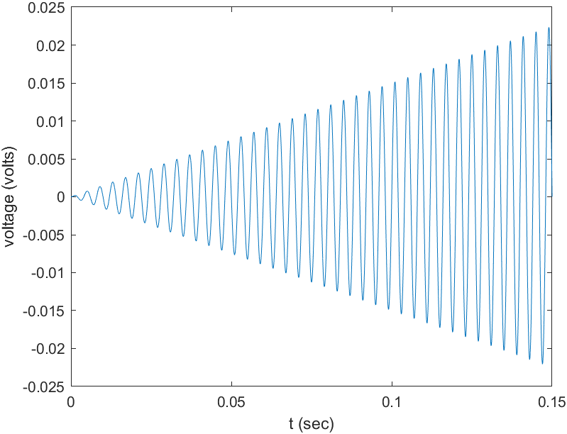

Figure 22: Multiplying Sinusoidal and Linear Voltages

t = 0:0.000001:0.15;

v1 = t;

v2 = 0.15*sin(2*pi*250*t);

f = v1.*v2;

plot(t,f);

xlabel("t (sec)");

ylabel("voltage (volts)");

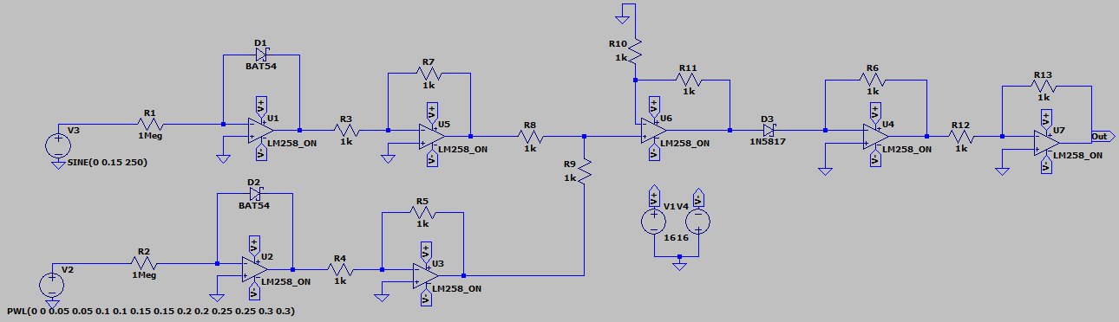

Figure 23: Multiplication Circuit of Sinusoidal and Linear Voltages

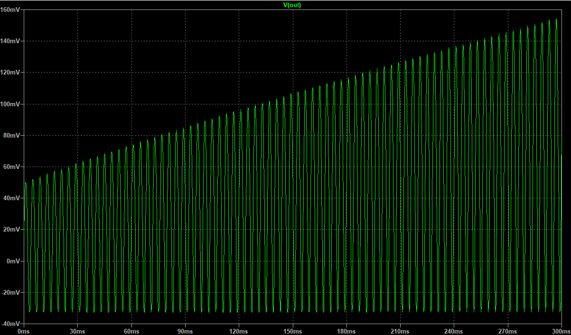

Figure 24: Output of Sinusoidal and Linear Voltages Multiplication

It is seen that output is in the form of sinusoidal wave, and its peak-to-peak voltage is increasing by time because of the voltage supplied from linear voltage source is increasing by time too. But only problem occurred here is some DC offset is occurred, output waveform is perfectly sinusoidal but with DC offset. Even though, output result is acceptable.

## **Linear and Pulse Voltage Sources**

In this part we will test the circuit with two linear voltage sources. Inputs are given by:

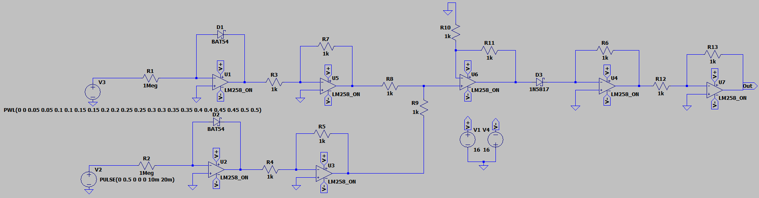If we predict theoretical output, we say that the output waveform is in the square wave too, but peak-to-peak voltage of it is increasing by time because of linearly increasing voltage.

Figure 25: Multiplication Circuit of Pulse and Linear Voltages

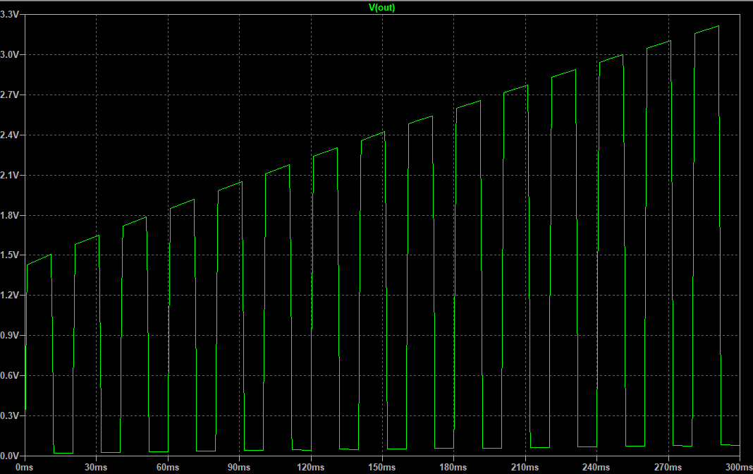

Figure 26: Output of Pulse and Linear Voltages Multiplication

From Figure 26, we can conclude that the output is in the form of Pulse waveform, and its peak-to-peak voltage is increasing by time because of linear voltage.

# Division Function Circuit

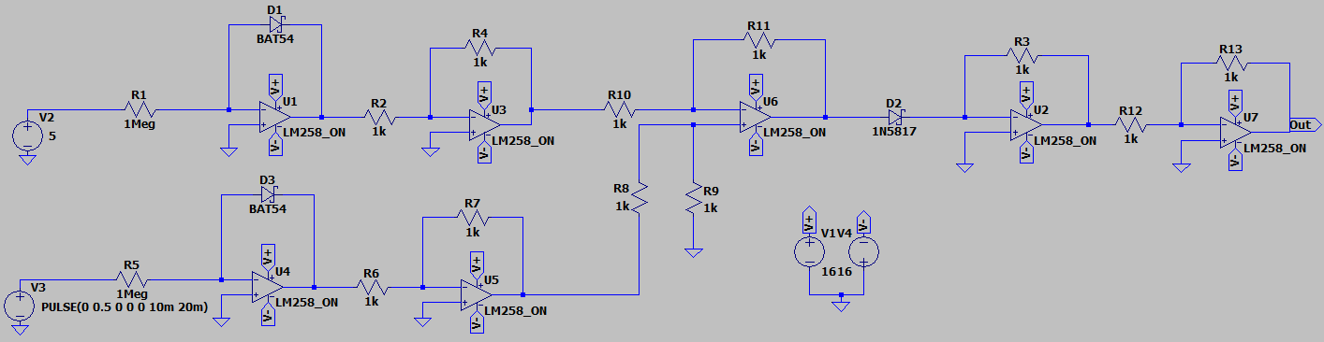In analog electronics division process is also obtained using log-antilog terms. Let us show the circuit first and then explain how it works step by step.

Figure 27: Divider Function Circuit

Let us explain the circuit using block diagram.

INVERTER

INVERTER

INVERTER

ANTILOG

LOG

LOG

SUBTRACT

Now if we consider the block diagram step by step: (Assuming parameters are the same for all diodes.)

Step 1: Natural logarithm of inputs are calculated.

Step 2: Negative sign is not desirable. Therefore, inverters are used.

Step 3: Remember the property of logarithm. , that is, non-inverting summing amplifier is required to use.

Step 4: Take its antilog.

Step 5: Negative sign is not desirable. Therefore, inverter is used.

Notice that, inputs are multiplied and scaled with some constant K.

## **AC and Linear Voltage Sources**

In this experiment we use 2 different input sources which are given by:

Let us observe theoretical output using MATLAB:

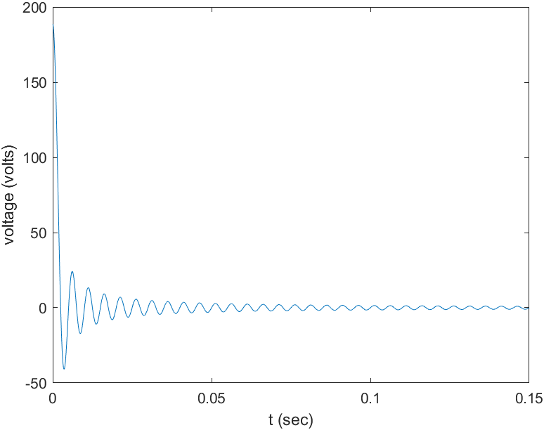

Figure 28: Dividing Sinusoidal by Linear

t = 0:0.000001:0.15;

v1 = t;

v2 = 0.15*sin(2*pi*200*t);

f = v2./v1;

plot(t,f);

xlabel("t (sec)");

ylabel("voltage (volts)");

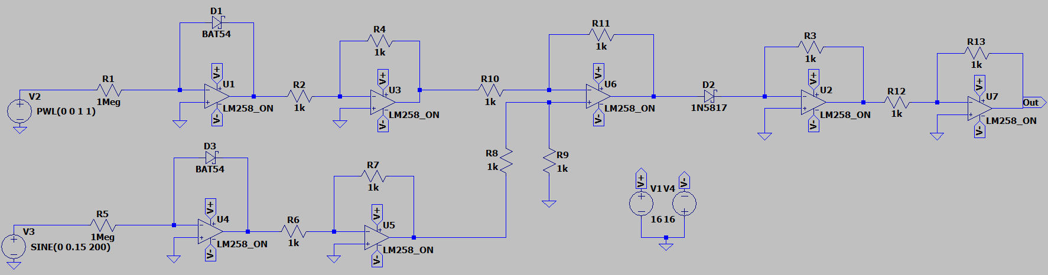

Figure 29: Division Circuit of Sinusoidal Voltage by Linear Voltage

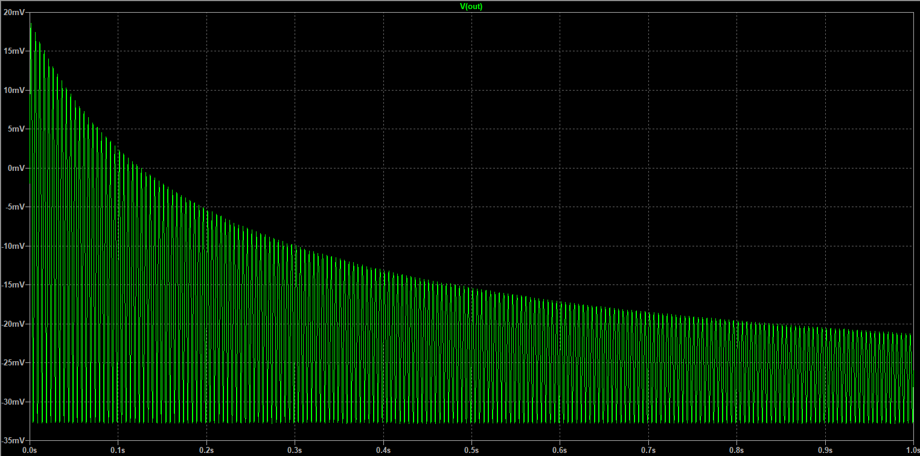It is clearly seen that from Figure 30, output is in the form of sinusoidal and its voltage is decreasing by time as we expected. This decrease occurs due to increasing linear voltage, because if we divide the same peak voltage of sinusoidal input by linear voltage increasing by time, the output will be decreasing time by time. Only problem here is some DC offset is occurred in the output. But still output is acceptable because it gives us an idea about theoretical result.

Figure 30: Output of Sinusoidal Voltage Divided by Linear Voltage

## **Pulse and Linear Voltage Sources**

In this part we will test the circuit with two linear voltage sources. Inputs are given by:

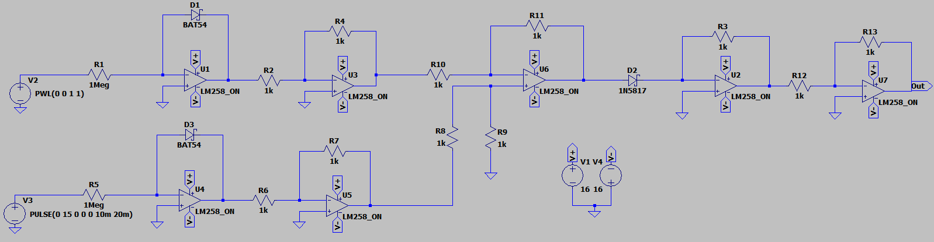If we predict the output, we say that output should be in pulse waveform but with decreasing peak-to-peak voltage by time due to increasing linear voltage by time.

Figure 31: Division Circuit of Pulse Voltage by Linear Voltage

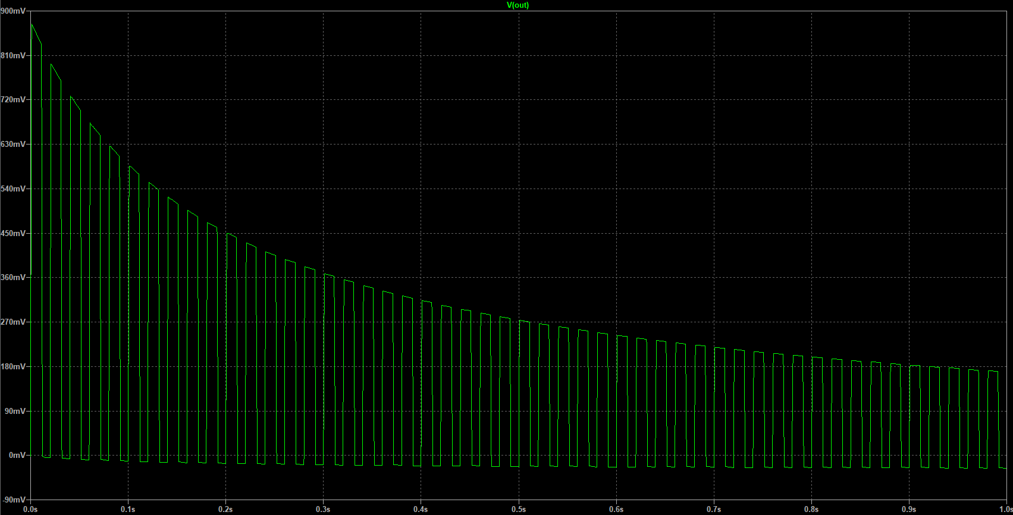From Figure 32, we can conclude that the output is in the form of Pulse waveform, and its peak-to-peak voltage is decreasing by time because of increasing linear voltage.

Figure 32: Output of Pulse Voltage Divided by Linear Voltage

## **Pulse and AC Voltage Sources**

In this section we will use two different voltage sources which are given by:

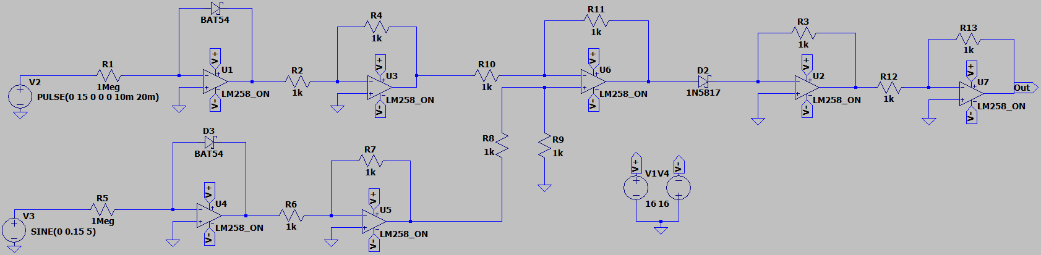Theoretically, we expect that something like sinusoidal waveform but with pulse signals. Let us test the theory.

Figure 33: Division Circuit of Pulse Voltage by Sinusoidal Voltage

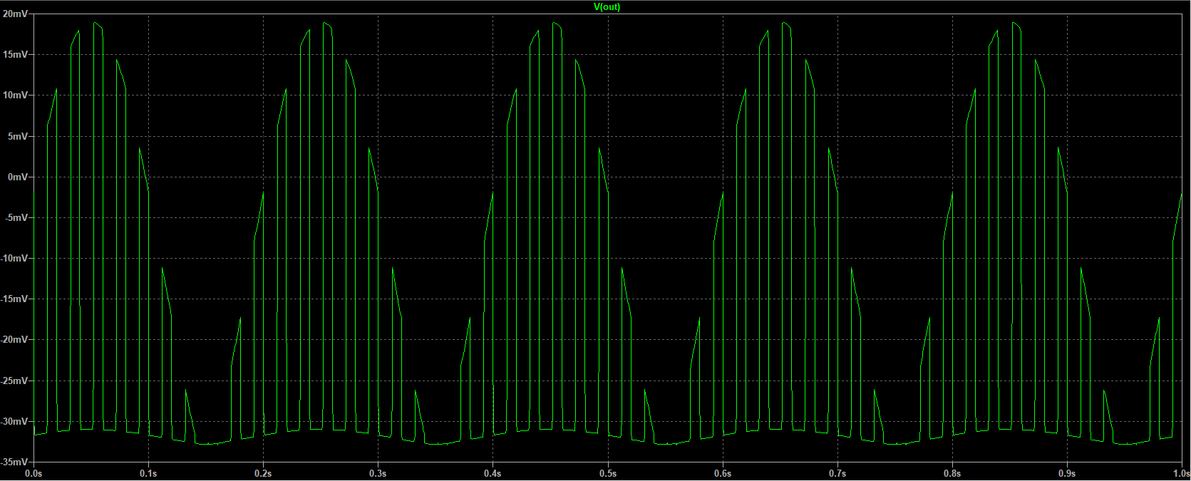As it is seen from Figure 34, our expectations are met, but with some error. The error is that in reverse direction diodes are closed, thereby we can see only positive half waves in the output. To solve this problem, some DC offset can be introduced to sinusoidal input. Anyway, output is satisfying though.

Figure 34: Output of Pulse Voltage Divided by Sinusoidal Voltage

# Square Function Circuit

Square function circuit is easy circuit to obtain using multiplication function circuit. Way to do that is connect common mode input which is obtained by connection inputs of log function circuit together. Thereby, the circuit designed as:

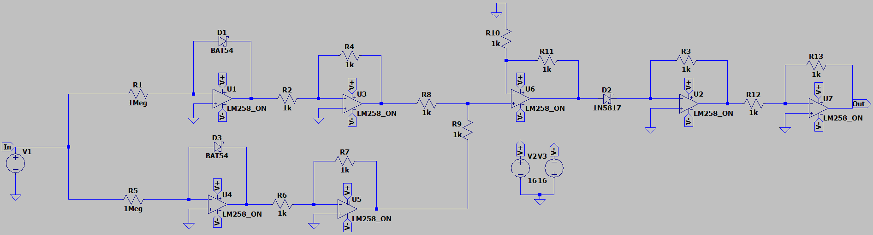

Figure 35: Square Function Circuit

Let us remember the formula obtained from multiplication function circuit:

But now we have same inputs which means:

Then we can simplify the equation as:

It is seen that input voltage is squared and multiplied with some constant K.

## **AC Voltage Source**

In this part we will give input of sinusoidal waveform. First, let us see the theoretical output using MATLAB:

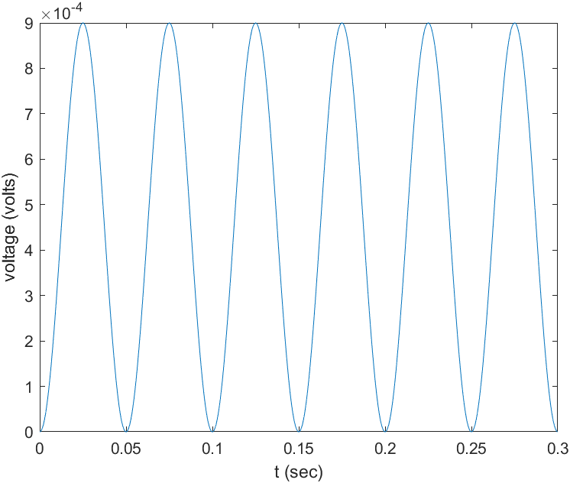

Figure 36: Theoretical Output of AC Input

t = 0:0.000001:0.3;

v = 0.03*sin(2*pi*10*t);

v = v.*v;

plot(t,v);

xlabel("t (sec)");

ylabel("voltage (volts)");

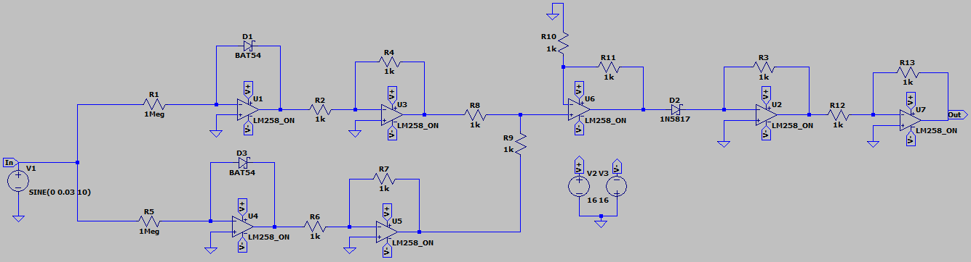

Figure 37: Square Circuit of AC Input

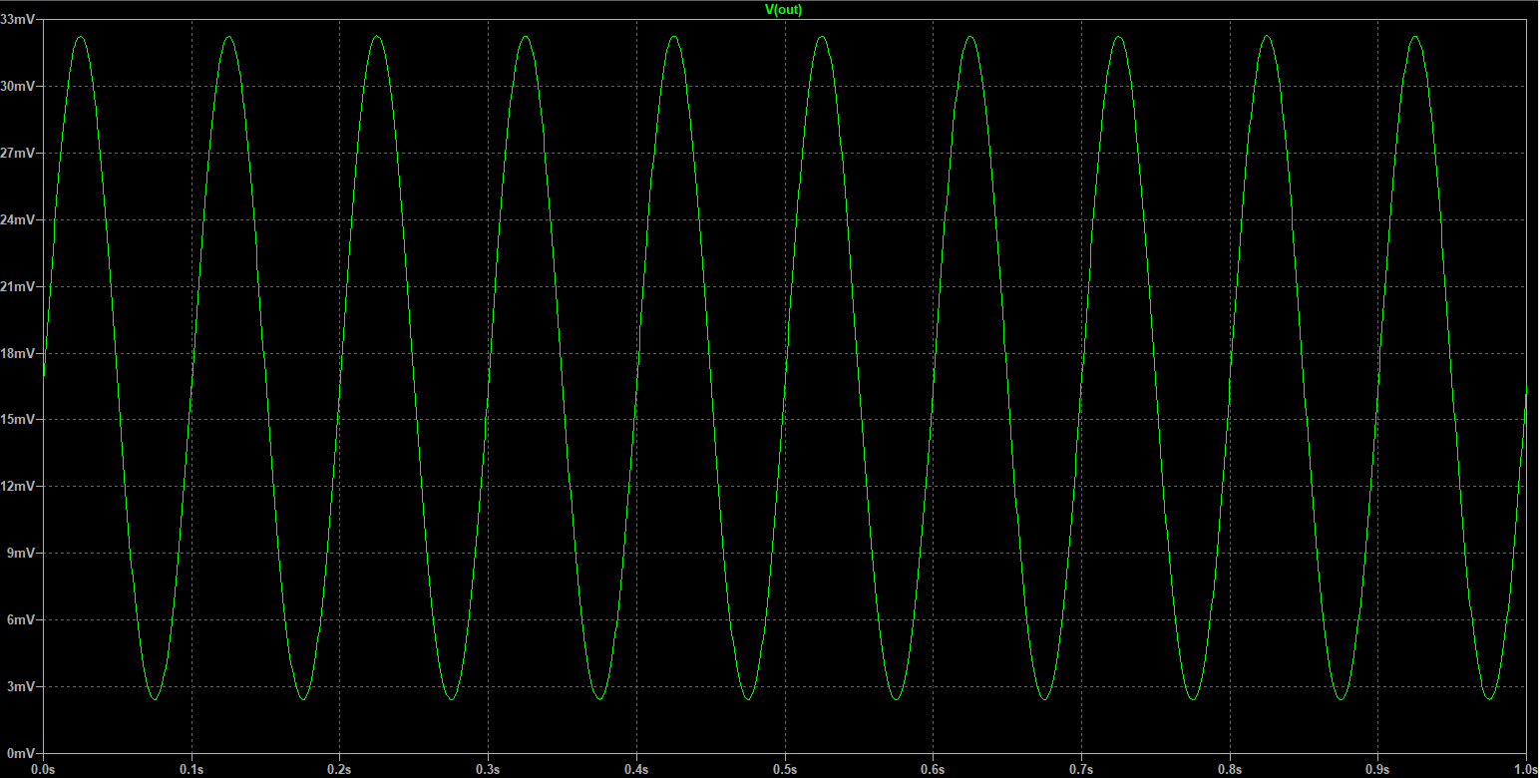Figure 36 and Figure 38 are matched, in other words they are both in same shape and please notice that they both do not have any negative voltages due to square. So that, we can say that the design works fine.

Figure 38: Output of Sinusoidal Voltage

## **Linear Voltage Source**

In this section we will give input of linear waveform. First, let us see the theoretical output using MATLAB:

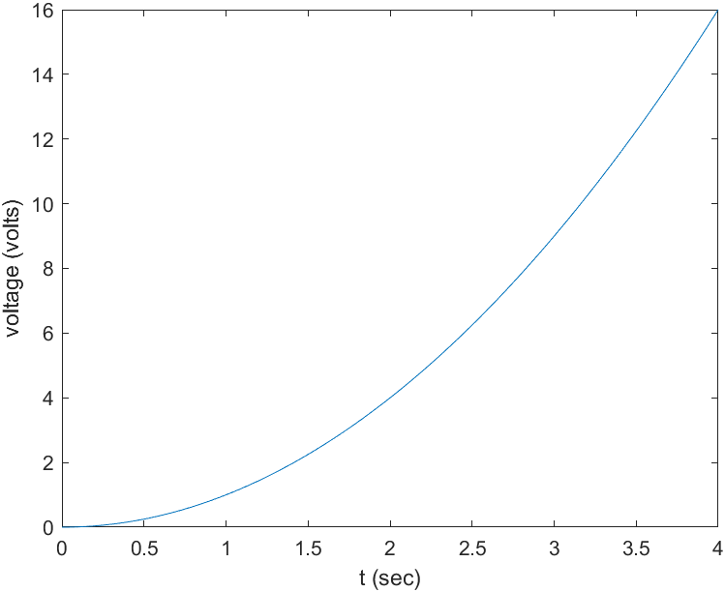

t = 0:0.000001:4;

v = t;

v = v.*v;

plot(t,v);

xlabel("t (sec)");

ylabel("voltage (volts)");

Figure 39: Theoretical Output of Linear Input

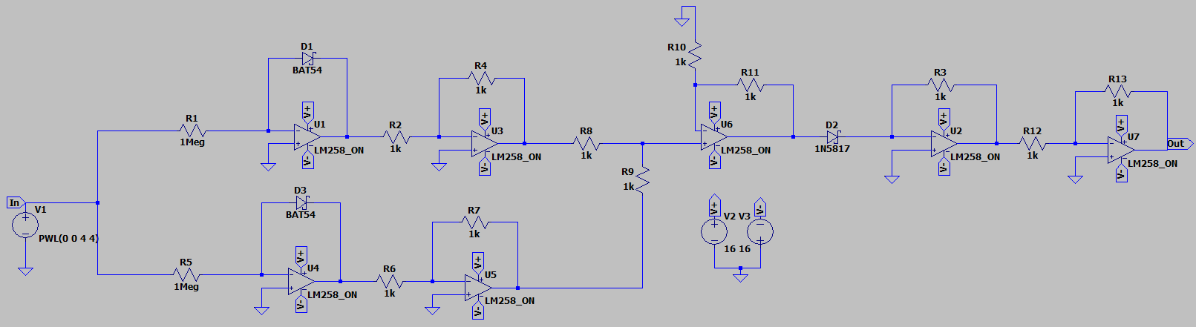

Figure 40: Square Circuit of Linear Input

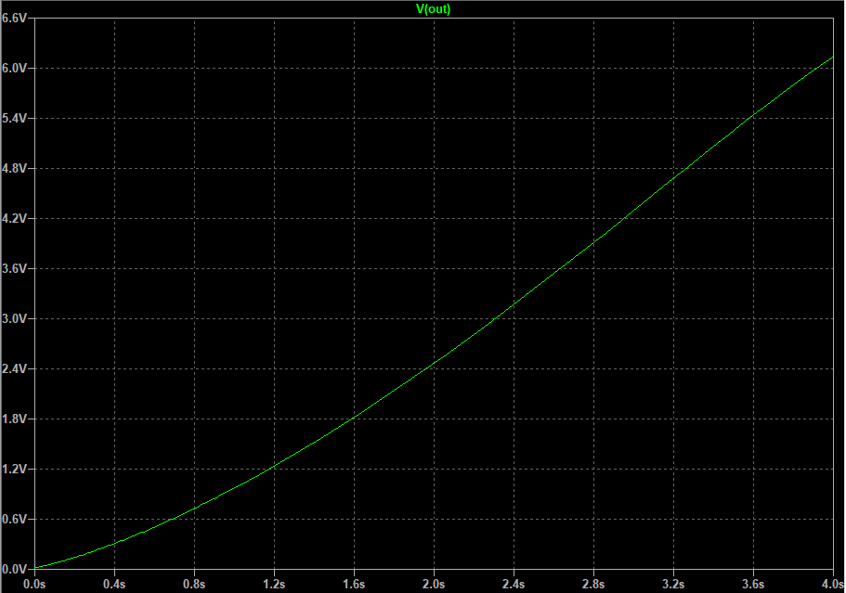

Figure 41: Output of Linear Voltage

Notice that Figure 39 and Figure 41 are in same shape. Now because of the square of linear input is the output voltage increases more rapidly than before. Therefore, it is right to say that the designed circuit also works for this input.

## **DC Voltage Source**

In this part DC input will be tested. Given input is:

Then, theoretically output should be:

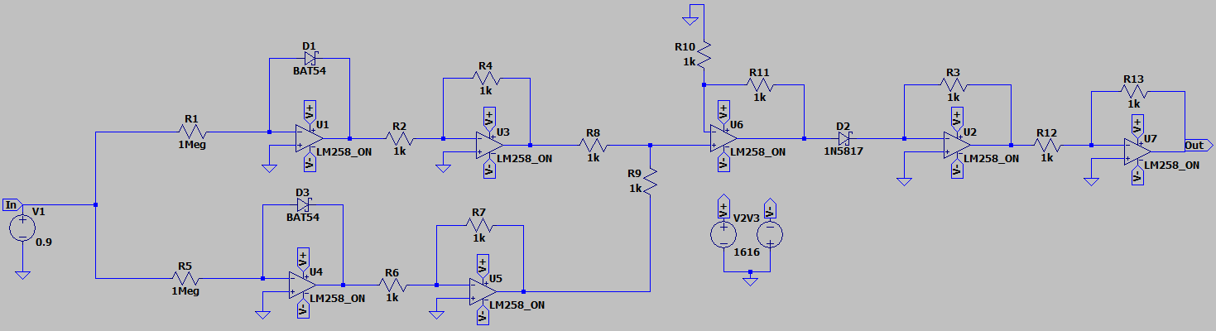Let us test the real circuit.

Figure 42: Square Circuit of DC Input

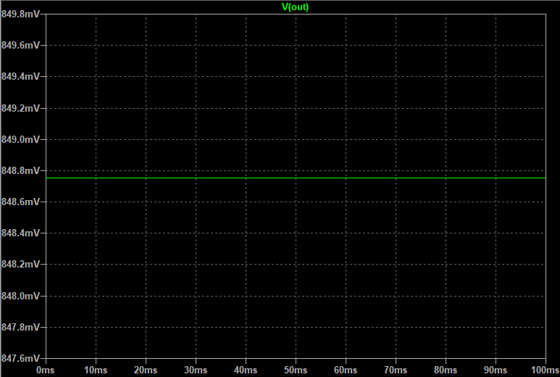

Figure 43: Output of DC Input

From Figure 43, we read the output voltage as 848.75 mV. Theoretically, it was 810 mV. Output shape satisfies our expectation but in voltage level some error is occurred.

# Conclusion

To sum up, in analog electronics **log** and **anti-log** mathematical operations are useful expressions to apply mathematical operations such as logarithm, anti-logarithm, multiplying, and division. We also observe that in designing process of the circuits the essential components are **operational amplifiers** and **diodes**.

# References

1. <https://components101.com/ics/lm258-op-amp-pinout-datasheet>
2. <https://www.tutorialspoint.com/linear_integrated_circuits_applications/linear_integrated_circuits_applications_log_and_anti_log_amplifiers.htm>
3. <https://www.electronics-tutorials.ws/opamp/opamp_5.html>